Build and Release Management

Lab

Name: RAJUL DUBEY

SAP ID: 500069424

DATE 21-01-2021

AIM:

1. Create a Java Project using Maven

2. Run the following maven goals on this project

i) Clean

ii) Compile

iii) Test-Compile

iv) Install

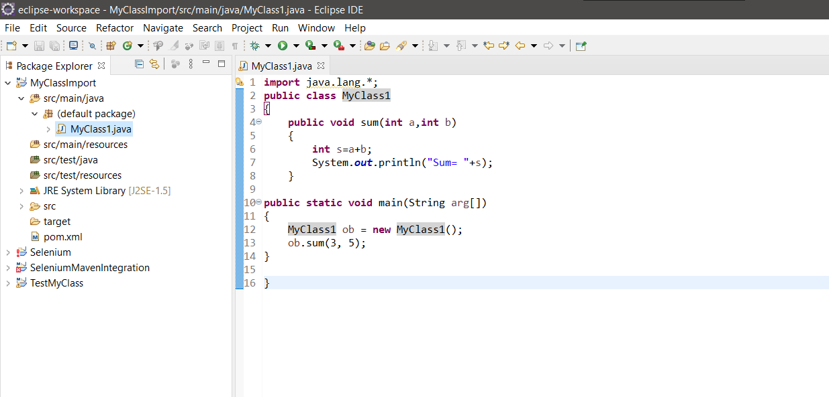

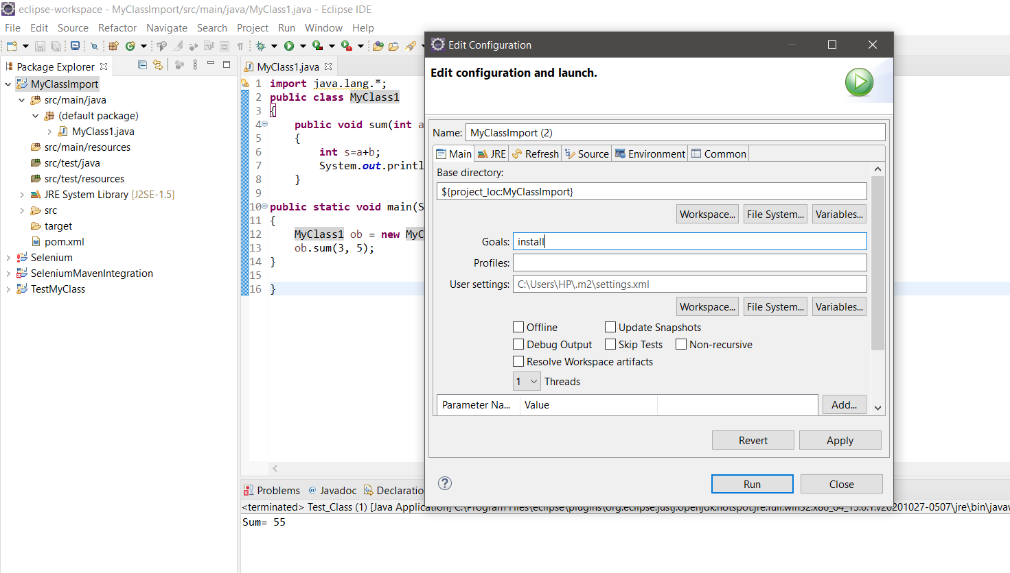

Test Project

